**Practice**

**Instruction**: Create single user, group and multiple users base on the following tasks

1. Create User **web2024** with user ID 4000 and description as “WEB Student”.

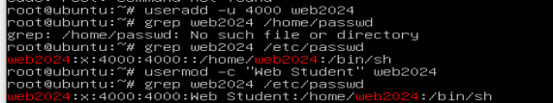

1. Use command **grep** to display information of user **web2024** in file /etc/passwd.



1. Create a group name **G-WEB** with group ID 3000.



1. Create 2 more groups **G-Backend** and **G-Frontend.** Then view group information in file /etc/group.



1. Add user **web2024** to be a member of group **G-WEB** (as Primary) also add to group G-System and G-Network (as Secondary).
2. Gain access to group **G-WEB** be able to type any command as superuser.
3. Switch login to use **web2024**, then create another user name “testing” to verify if user web2024 can execute the command by using “**sudo**”. Logout from you web2024 after finished the command.
4. Logout from web2024 user, then create two more users account name “linux1” and “linux2” as the following requirements:
   1. User “linux1”
      * Password: linux123
      * Description: User Linux 1 for testing
      * UID: 1500
      * Primary group: G-SNA
      * Secondary group: G-System
   2. User “linux2”
      * Password: linux123
      * Description: User Linux2 for testing
      * UID: 1600
      * Primary group: G-SNA
      * Secondary group: G-Network
   3. Verify the user accounts have been created.
5. Lock the linux1 user account. Try to login as linux1. Does this work?
6. Unlock the linux1 use account. Try to login again. Does this work?
7. Display the password information of user linux2 using command “**chage**”.
8. Change setting of user linux2 account password parameters as following:
   1. Password maximum usage of user is **100** days
   2. Warning days: **3** days before password expires
   3. Account expires: in next **365** days
9. Force this user “linux2” to change password immediately after logon. Try to login as linux2. Does this work?